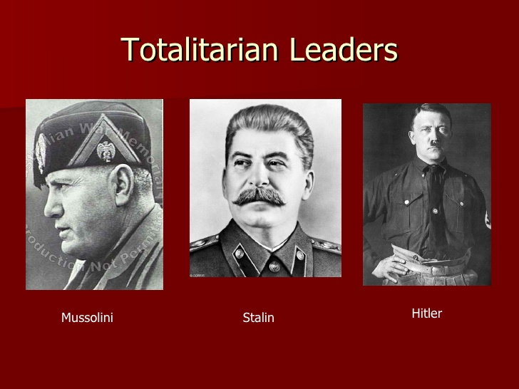

 

 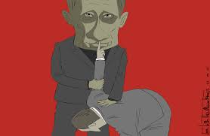

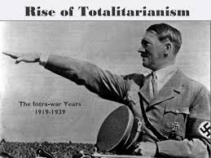 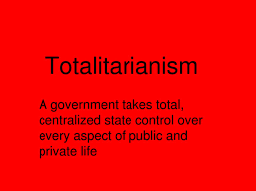

GREAT DEPRESSION

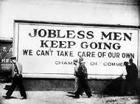  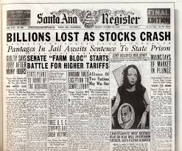

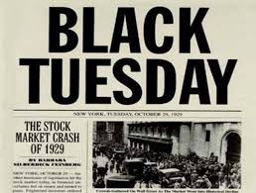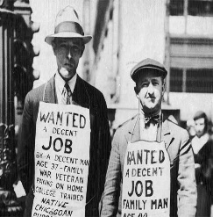

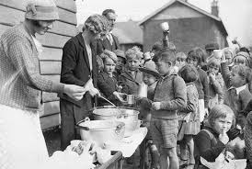 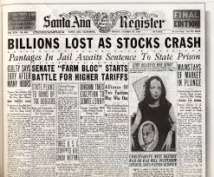

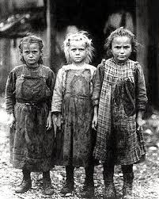 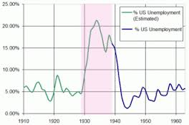

New Deal pictures

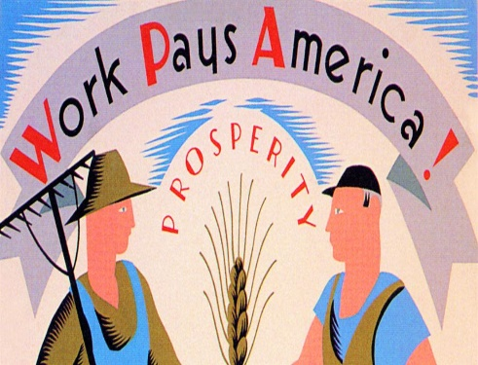 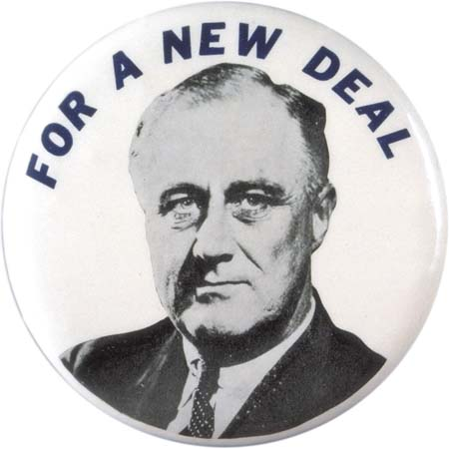 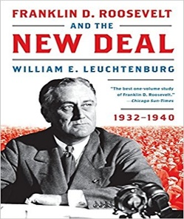

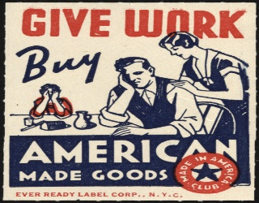 [](http://www.google.com/url?sa=i&rct=j&q=&esrc=s&source=images&cd=&cad=rja&uact=8&ved=0ahUKEwisqa_E85LTAhUIxVQKHYsFCUgQjRwIBw&url=http://www.history.com/topics/new-deal/pictures/new-deal-programs/by-vera-bock-2&psig=AFQjCNEGLvDwNx4tbs4gpFjGYrvPqgH1WQ&ust=1491673607896912) [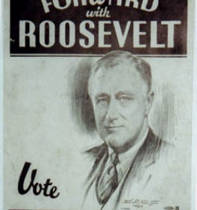](https://www.google.com/url?sa=i&rct=j&q=&esrc=s&source=images&cd=&cad=rja&uact=8&ved=0ahUKEwj_yrLq9JLTAhVBllQKHRDMA1kQjRwIBw&url=https://www.pinterest.com/pin/51298883226229531/&psig=AFQjCNEGLvDwNx4tbs4gpFjGYrvPqgH1WQ&ust=1491673607896912) [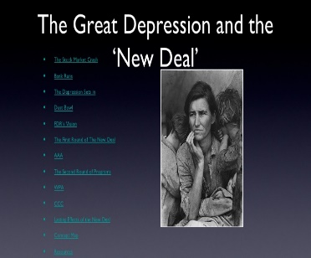](https://www.google.com/url?sa=i&rct=j&q=&esrc=s&source=images&cd=&cad=rja&uact=8&ved=0ahUKEwj766et9ZLTAhVmqVQKHZAXCI0QjRwIBw&url=https://www.slideshare.net/schubera/new-deal-ppt-364948&psig=AFQjCNEGLvDwNx4tbs4gpFjGYrvPqgH1WQ&ust=1491673607896912)

 

   

 

Onset of ww2

